**T2** 2023

Coverity Scan Static Analysis Report

Hardhard Enterprises

Statement of Intent

Overview

This document aims to provide a record of static code analysis performed on a specific issue from the Coverity SAST scan for the NASA ION Open-Source code 4.1.1 project.

The primary purpose of this document is to validate the issue identified via the automated detection process to eliminate false positives.

Depending on findings, secondary purposes can include but are not limited to listing/providing recommended fixes alongside a list of attack vectors and potential exploits for consideration.

Reporting Best Practices

Please ensure best practices are kept when completing the document via regularly updating the Acronyms and Abbreviations table alongside any iterations made to the Document History table. This will allow other members to identify any updates and progress made across trimesters easily.

When using code snippets, please use screenshots that are clear and easy to read, alternatively, use words built-in code formatter found [here](https://appsource.microsoft.com/en-us/product/office/WA104382008?tab=Overview).

Document Naming Conventions

Naming conventions for this file are as follow; SAR_{CID}. For example, when investigating issue 123456 the file name would be SAR_123456.docx

Document History

|  |  |  |  |
| --- | --- | --- | --- |
| **Dates** | **Version** | **Author** | **Comments** |
| 21/9/2023 | V0.1 | Chong Zhang | Initial document |
|  |  |  |  |
|  |  |  |  |

Table of Content

Contents

Introduction 3

Objective 3

Scope 3

Acronyms and Abbreviations 3

Code Review and Analysis 4

Outcomes 4

Observations 4

Supporting Evidence 4

Conclusions and Recommendations 4

References 5

Appendix 6

# Introduction

## Objective

The primary objective of this analysis is to determine whether the defects identified in the Coverity Report for the ION Open Source 4.1.1 project are:

* Indeed, defects.
* Potentially exploitable.

The secondary objective of this analysis, where applicable, is to provide the following:

* Recommendation(s) to fix.
* Any exploit for consideration.

## Scope

This static code analysis is limited to the ***Untrusted loop bound*** type defect identified in the following CIDs:***1520822***

# Acronyms and Abbreviations

Please keep an updated list of acronyms and abbreviations used throughout the report.

|  |  |
| --- | --- |
| **Acronym** | **Meaning** |
| DTN | Delay/Disruption Tolerant Network |
| ION | Interplanetary Overlay Network |
| CID | Coverity Issue Identification Number |
| CWE | Common Weakness Enumeration |

# Code Review and Analysis

## Overview

Coverity identifies **CID-1520822 Untrusted loop bound** as a Medium vulnerability, and the category is insecure data handling. It appears in **purgePlanXmitElt**: An unscrutinized value from an untrusted source used as a loop bound (CWE-606). This means an attacker could control the number of times the loop iterates.

## Observations

The issue can be found in the purgePlanXmitElt function in the /bpv7/library/libbpP.c file. The purpose of this function is to purge PlanXmitElt. In this case, the tainted function sdr_stage contaminates the parameter plan. The function removeBundleFromQueue uses the tainted argument plan as the loop boundary. An error in the plan value results in bundles that are not all removed from the queue. This may cause errors in the output or system errors.

The problem starts on line 2804, which calls the tainted function sdr_stage. This causes the parameter plan to be tainted. On line 2805, the target function calls removeBundleFromQueue with the plan argument as the loop boundary.

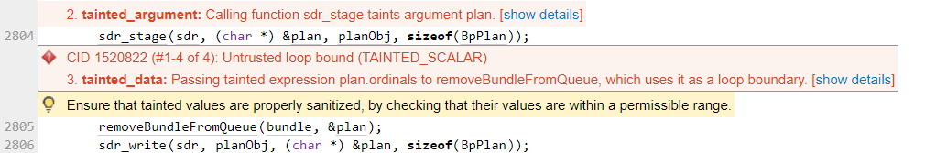

Fig. 1. Coverity Static analysis results

## Supporting Evidence

Please provide any supporting evidence, and feel free to make references to documents in the appendix.

# Conclusions and Recommendations

This is a vulnerability, and it can be fixed. The attacker can control the number of loops to cause system crash or output error.

The source of this problem is that the _sdrfetch function of the file /ici/sdr/sdrxn.c calls the tainted function read. The read function reads data and returns its value. It is recommended that modify the code to ensure that the read function works correctly. Code Example:

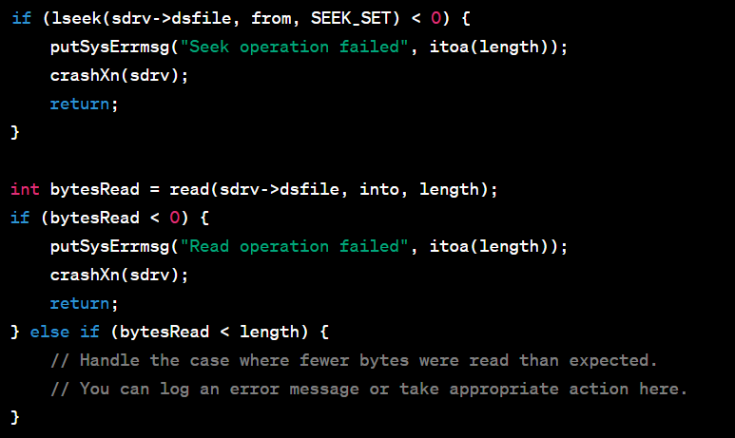

References  
Common Weakness Enumeration (n.d.) CWE-606: Unchecked Input for Loop Condition, <https://cwe.mitre.org/data/definitions/606.html>

Appendix

Include additional information/documentation here to help the readers understand complex information.